# Table of Contents

Introduction page 1

The Water Cycle page 4

An Irrigated Desert page 6

Water and Capitalist Development in California page 7

Water Privatization California Style page 9

Westlands Water District page 10

Kern Water Bank page 12

What Can Be Done page 15

**Appendix A** page 19

Fracking in California page 19

The Importance of the Sacramento/San Joaquin Delta page 20

The Situation in the Imperial Valley of California page 23

**Appendix B** page 24

Clean Water Act page 24

California Endangered Species Act page 24

Monterey Agreement page 24

Water Systems in the State of California *graphic* Back Cover

Special thanks to the following individuals for their technical help in creating this document: Gloria M Sandoval, Bill Hatch, Steve Miller, David Ransom, Sandy Reid, Laura Garcia, Lloyd Carter, and to all others whose writing and research and strong advocacy I have depended upon. Errors contained are solely the responsibility of the author.

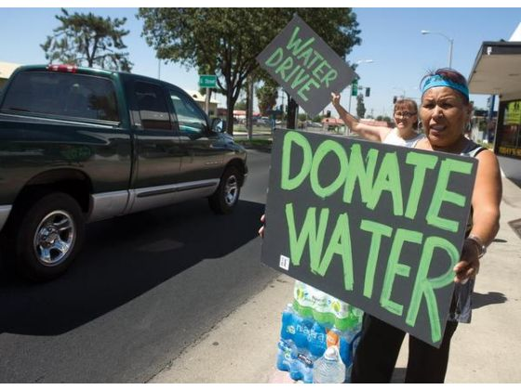

**Introduction**

As Californians experience one of the most severe droughts in recent memory, massive multi-billion dollar projects, financed at taxpayer expense, are proposed to channel and divert Northern California rivers to the San Joaquin Valley and Southern California. We are told that these projects are vital to our economy, food production, jobs, and way of life. What we are not told is who really stands to benefit, what the very real dangers to our environment are, what the costs to future generations will be, and what alternatives exist.

While enduring the shock of a fourth year of consecutive drought, Californians are led to believe that only their personal sacrifice and a massive outpouring of taxpayer money and further endangerment of the environment can salvage the situation. At the time of this writing, water rationing has gone into effect, reducing urban water use by over 30 per cent, while sparing agricultural interests who consume 80 per cent of the state’s water.

Overdrafting of groundwater (pumping out more than can be replenished) is occurring at an alarming rate as confirmed by satellite images. This leads to land levels sinking (called subsidence) in places such as El Nido, California, where surface land has collapsed due to depletion of the underlying water table. It has led small rural communities such as East Porterville and Fairmead to run out of drinking water for their residents, whose wells cannot match the depth of the large wells of adjacent large agricultural interests. In addition, some unscrupulous individuals have sold groundwater from already low aquifers which extend under neighboring farmland and communities.

Under the guise of economic calamity and loss of jobs due to the drought, powerful interests are taking control of publicly subsidized water systems for personal gain. They have influenced state and federal officials to divert water to them, despite environmental laws on the books such as the Clean Water Act and the Endangered Species Act (see appendix B).

We are not being told why all of this is happening. Previously, the massive water works that cover our state permitted the development of metropolitan areas such as exist in the Bay Area, Southern California, and cities dotting the great expanse of the Sacramento/San Joaquin Valley, along with thriving industries and employment in both urban and agricultural areas. Back then, it seemed that capitalism and massive water works were compatible with a thriving near full employment economy and a constantly improving standard of living. All of this was lubricated by water and public money, enabling the economic and political clout that politicians and the captains of manufacturing and agricultural industry wielded. Back then it seemed that what was good for industry was good for society, and that the politicians were looking out for all of our interests.

Today however, our reality is much different. On the one hand, the industries that once fueled industrial jobs are gone, and entirely new industries that require many fewer workers are arising in telecommunications, international business and commerce, and high tech industries such as exist in the Silicon Valley. Even agricultural production is on the cusp of robotizing, as private/public ventures at publicly funded universities begin to replace agricultural workers. In many parts of the state, San Jose for example, the work force is rapidly being partitioned into a handful of Google.com highly paid workers on one extreme counter posed to the dispossessed, the barely working, the unemployed, the homeless–and the rest of us–all struggling to survive.

**Human rights vs. for profit**

Meanwhile, the fragile, semi-arid environment of the San Joaquin Valley is in peril. The San Joaquin/Sacramento Delta is on the brink of collapse. Air pollution from the contaminated Salton Sea in the Imperial Valley and the heavily drilled and fracked Bakersfield area in the south part of the San Joaquin Valley contribute to one of the highest asthma rates in the nation. Global warming is a very real threat, and we are polluting the air, water, and land that future generations depend on.

We have to awaken to a new reality. Whereas in the past, water was used as a resource to advance the needs of society as well as industry, today its control is increasingly privatized for profit by corporate interests such as those that control the Westlands Water District, the Kern Water Bank, and the Metropolitan Water District.1 Yet, we and our grand children will be paying for their schemes, as for example, the proposed Twin Tunnels that Governor Brown is promoting. Water is becoming a commodity to be sold, and not a human right. The leading privateers of water in the state contribute heavily to state and federal election coffers to promote their interests by buying elections and installing their candidates. Their influence is only surpassed by the oil industry lobby in the state, which contributes the most money to California politicians.2 In addition, they share overlapping interests due to the large amounts of water required to frack for oil [see appendix A].

Our survival as human beings is integrally connected with the survival of the planet. One purpose of this pamphlet is to show that the water situation is understandable and resolvable in a way that benefits society and protects our environment. It touches on every struggle that working people are involved with in some way. And it has to be approached in a way that highlights humanity’s interconnectedness and dependence upon nature.

Our survival as human beings is integrally connected with the survival of the planet. One purpose of this pamphlet is to show that the water situation is understandable and resolvable in a way that benefits society and protects our environment. It touches on every struggle that working people are involved with in some way. And it has to be approached in a way that highlights humanity’s interconnectedness and dependence upon nature.

Porterville water drive. Photo by Chieko Hara, The Porterville Recorder

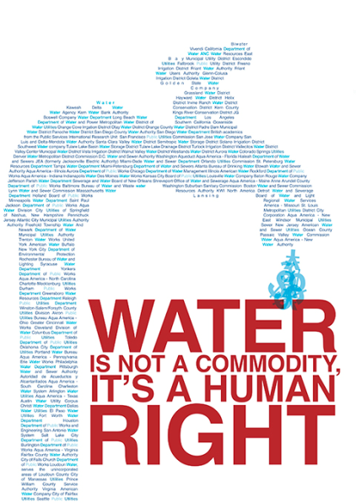

1

2

New industries that require many fewer workers are arising.

The dispossessed, the barely working, and unemployed… are struggling to survive.

1 Learn more at California Water Impact Network website article, “Paper Water: And Other Sordid Tales”

www.c-win.org

2 Read about the oil industry lobby’s influence on California politics at www.calitics.com

3